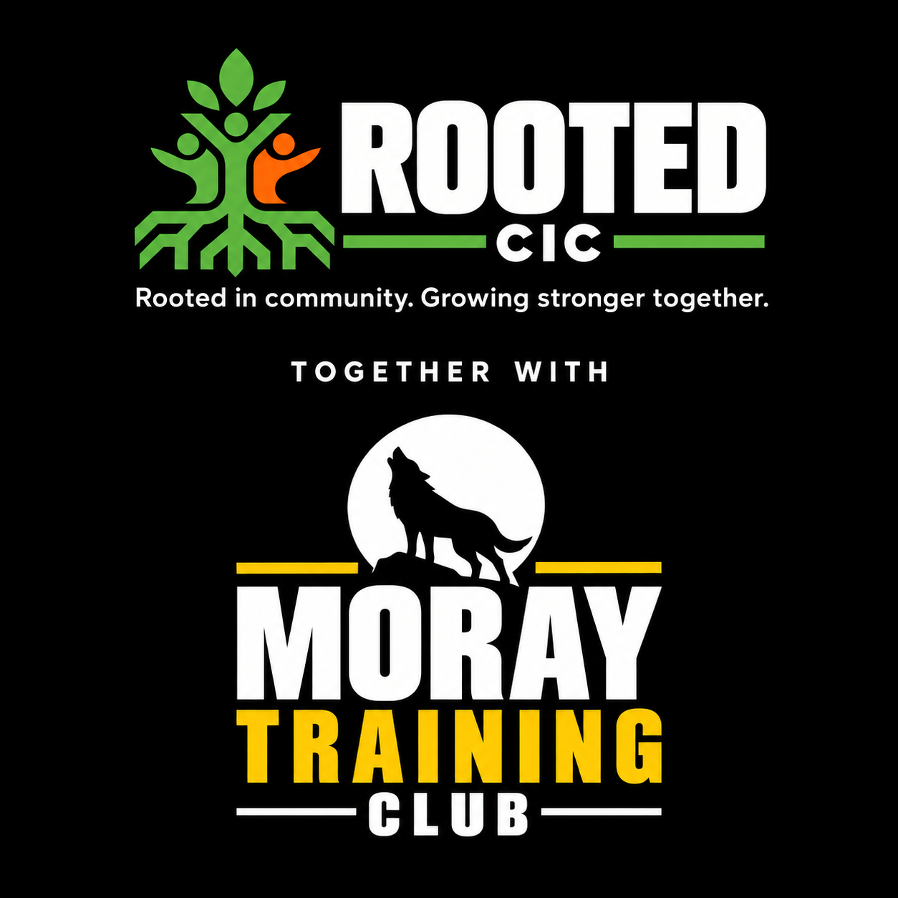

MTC Run Club and
Merry Miles 5K Race
BUSINESS PLAN | OCTOBER 2026
Weekly Sunday runs and a December fundraiser
for Rooted CIC
Prepared for the MTC and Rooted team
Proposal by Leigha and Daniel

The business proposal
  - Business plan for a weekly community run club and a December fundraising race
Prepared by Leigha and Daniel for the MTC and Rooted team. Launch MTC Run Club on Sunday 25 October 2026 at 10am, with seven free training Sundays before Merry Miles on 13 December. Weekly sessions finish at The Den at normal cafe prices. The festive 5K supports Rooted CIC. In 2027, offer eight-week blocks with membership inclusion and paid non-member places. Training dates are 25 October; 1, 8, 15, 22 and 29 November; and 6 December.

The proposal
Activity | Proposed offer
MTC Run Club | Sunday run/walk at 10am from 25 October. All seven pre-race sessions free. Meet 9:45am and finish at The Den for optional purchases at normal prices.
Merry Miles 5K race | December festive race supporting Rooted CIC. £10 entry or £15 including an optional personalised gold finisher medal.
Race day café offer | 10% off coffee or hot chocolate at The Den for race participants on race day only. All purchases are separate from entry.

Why it could work
The free introductory period removes an initial price barrier. A consistent weekly meeting and café finish can encourage friendships and repeat attendance. Merry Miles provides a shared goal for beginners and a fundraising opportunity for the wider community. These are reasons to test the idea, rather than evidence of established demand.

Who it is for
Start the club with adults from MTC and the wider Lossiemouth community. Welcome beginners through a genuine run and walk option. More experienced runners can attend, with regroup points and clear expectations about pace. Race age limits and accessibility must be checked against the final course, licence and insurance before promotion.

Decision requested from the team
Agree the trial, named delivery roles and a small startup budget. Authorise route and insurance enquiries, and investigate a December race date. Do not commit to medal quantities or launch paid race entries until the delivery requirements and financial position are clear.

How MTC Run Club will operate
Leigha and Daniel propose to host the club. Sam can attend as the back-marker and trained first aider; Mike is expected to be at the gym. These roles remain subject to availability and the insurer accepting the arrangement.
Person | Proposed responsibility
Leigha | Front leader, route briefing, pace and regroup points. First aid training booked for 20 October 2026; qualification subject to successful completion.
Daniel | Co-leader within the group, participant support and communication with the front and back. Not currently first aid trained.
Sam | Back-marker and accompanying first aider. Confirm that qualification is current and suitable for the routes.
Mike | Gym contact and emergency backup. Being at the gym does not replace first aid cover on the route.

The Sunday session
Meet at 9.45am for check-in, introductions and a brief route explanation. Start at 10am with an easy warm-up, then run and walk for around 30 minutes, adjusting the distance to the group. Cool down, count everyone back in and finish at The Den at approximately 10.45–11am. Duration is a proposal, not a compulsory pace target.

Keep beginners included
Begin with one manageable group, short loops or an out-and-back route and planned regroup points. Offer short jogging intervals with walking recoveries. Progress according to attendance and ability; one weekly session alone does not guarantee everyone will run continuously for 5K by December. Add separate pace groups only when leadership and first aid cover support them.

Bookings and café use
Use MTC app bookings if non-members can access them; otherwise use a simple registration form. Trial cap: 15 participants, to be adjusted after the route and staffing assessment. Collect contact and emergency contact details, attendance and relevant support information securely. Do not require marketing consent to take part. Coffee, cake and other café purchases after weekly sessions are charged at normal prices. There is no weekly run club discount. Keep a weekly register of starters, returns and early departures. Publish an age policy, cancellation channel and brief privacy information; use separate optional permission for promotional photos.

Staffing continuity
Volunteer delivery is proposed for the trial. Confirm each person’s availability and identify cover before advertising a recurring service. Cancel or adapt the session if required leaders or first aid cover are absent, or the route is unsafe. Review the workload after four sessions before committing to a permanent schedule. Plan all seven free sessions, with a review after the first four. Set a named backup rota and a clear go or cancel decision for each Sunday.

Delivering the Merry Miles 5K race
Planned date: Sunday 13 December 2026, with a proposed 10am start. Confirm venue access, route, staffing and event approvals before opening paid entries. MTC is the preferred base if a suitable course can be arranged.

Race format and permissions
The requested format is a race. Published times or prizes for finishing places trigger Scottish Athletics race licensing requirements [1]. Contact its events team immediately about organiser membership, the appropriate licence, course measurement, timing, officials and participation rules. Its published guidance asks for applications at least eight weeks ahead; for 13 December, that point is 18 October.
Obtain landowner permission and ask Moray Council which approvals the proposed route needs. Council guidance says even small events on its parks and open spaces take at least four weeks to process, with larger or more complex events taking longer [2]. Avoid assuming public access rights permit a managed event or that gym insurance automatically covers an outdoor race.

Course and event staffing
Walk and assess a measured 5K route with minimal road crossings, safe passing space and emergency access. Confirm the finish area, toilets, parking, weather exposure and café capacity. Set the entrant cap after this assessment. Recruit dedicated check-in volunteers, course marshals, finish staff, a back-marker and suitable first aid provision; obtain timing and official support required by the licence. Do not rely solely on the three club hosts for a 100-person race. Keep a route map with marshal locations, regroup points, emergency access and a shorter alternative. First aid cover must be available on the course; a first aider acting as back-marker cannot simultaneously cover the finish.

Participant experience
Use the prepared bibs numbered 001-100, with waterproof printing arranged before race day. Allow four safety pins per participant plus spares. Use a shared start and manual stopwatch timing, with one volunteer recording elapsed times and another recording bibs in finish order. Rehearse the process and have a backup stopwatch. Encourage optional festive dress and costume prizes; any placing awards must fit the confirmed race arrangements.

Medals and The Den
Standard entry is £10; entry with a medal is £15. The selected Budget Trophy gold medal has the Merry Miles design and a green ribbon. The supplied basket shows 100 personalised medals for £120 (£1.20 each), with VAT included and shipping showing £0. Confirm the checkout total, print size and delivery date before ordering. Test a sample and budget separately for spare medals.
Both race ticket types receive 10% off coffee or hot chocolate at The Den on Merry Miles race day only. Display the race number to redeem. Food, cakes and other drinks remain full price, and all café purchases are separate from the entry fee. Plan café staffing, stock, queues and allergy information. Weekly run club sessions carry no café discount.

Budget and fundraising forecast
These figures are planning scenarios, not supplier quotes or guaranteed fundraising. They assume every entrant attracts a £3 unaffiliated levy under the licensed-race model [1]. Confirm how this affects the £10 and £15 advertised prices: the forecast absorbs it within those prices. Affiliated entries may reduce this cost. Medal costs use £1.20 each from the 100-medal basket; the same rate at 50 or 150 medals is assumed and must be confirmed. Spare medals are not included.
Cost or income | Planning basis
Race entry | £10 without a medal or £15 with a medal.
Medal | £1.20 each in the supplied 100-medal basket (£120 total), including design and green ribbon. Confirm checkout and other quantities.
Unaffiliated levy | £3 per entrant assumed for budgeting.
Payment processing | £0.50 per entry allowance; replace with actual rates.
Other race costs | £500 fixed allowance for organiser membership, first aid, officials or timing, permissions, signs, pins, delivery and contingency. Not a quote; may be insufficient.
Club startup | Separate provisional £150 cap for kit, visibility items and small incidentals. Training, insurance increases and paid staffing excluded until quoted.

Scenario | Income | Medals | Levy | Fees | Other | Balance
50 all with medals | £750 | £60 | £150 | £25 | £500 | £15
100 half with medals | £1,250 | £60 | £300 | £50 | £500 | £340
100 all with medals | £1,500 | £120 | £300 | £50 | £500 | £530
150 all with medals | £2,250 | £180 | £450 | £75 | £500 | £1,045

What the figures mean
At 100 medal entries, the projected surplus is £530, or £380 after the £150 club startup allowance. These are planning estimates. The £500 fixed allowance includes a provisional £75 for waterproof bibs; replace this with a quote. Training, extra insurance and spare medals may add costs. A 60p fee per medal entry instead of 50p would reduce the surplus by £10. Fund an inflatable arch separately if wanted.
At these assumptions, contribution is £6.50 for a standard entry and £10.30 for a medal entry. The £5 medal upgrade contributes £3.80 after the medal cost. Covering £500 of fixed race costs requires approximately 77 standard entries or 49 medal entries, if the £1.20 rate applies at that quantity. Confirm quantity pricing before using these break-even figures. Sponsorship covering fixed costs would improve fundraising.

Launch plan and measures of success
Timing | Action and proposed owner
Early October | Team agrees the concept and responsibilities. Leigha and Daniel assess routes; Mike confirms insurance enquiries. Contact Scottish Athletics and Moray Council immediately for the race.
Before the club launches | Confirm cover, leader requirements, route assessment, booking process, emergency plan and café arrangements. Begin only when these are in place.
First seven Sundays | Run a free introductory period. Record attendance, repeat visits, beginner feedback, café visits and volunteer workload.
By early November | Confirm race feasibility and quotes. Open paid entries only once the event arrangements are secured. Promote through MTC, Rooted, members and local partners.
Supplier deadline | Close medal bookings according to confirmed production and delivery times. Order prepaid quantities plus a budgeted small reserve.
Race week | Brief staff, confirm first aid and officials, test timing and bibs, review weather and contact entrants with instructions.
After the race | Publish results and thanks, reconcile accounts, report the net amount for Rooted and complete required licence returns and levy payments.

Targets for the trial and race
Proposed club target: 8–15 attendees per session and at least half returning for another session during the trial. Ask beginners whether the pace and welcome worked. Record café purchases only in aggregate. Continue if delivery is sustainable and participants want to return; adapt if turnout or retention is weak.
Proposed race planning target: 100 paid entrants, subject to course capacity. The minimum viable turnout depends on confirmed costs and sponsorship. Keep a weekly booking count and use a supplier-informed decision date before committing to non-refundable expenditure. These are targets, not turnout predictions.

Main risks and responses
Low entries: avoid large advance medal orders and seek sponsorship. Bad weather or ice: agree postponement, cancellation and refund terms before selling tickets. Leader absence: arrange cover or cancel clearly. Beginner pace mismatch: use run and walk intervals and regroup points. Café queues: stagger arrivals and plan service capacity. Permissions or licensing delays: move the race date rather than assume approval.

Promotion and next steps

Launch through the MTC community
Use one main coastal poster and a booking link or QR code. State: Starts Sunday 25 October; meet at MTC at 9:45am; run at 10am; free introductory sessions; run/walk welcome; finish at The Den for optional coffee and cake at normal prices. Collect interest and preferred pace, then confirm places within capacity. Invite members to bring a registered friend.
Promote Merry Miles once its arrangements are confirmed. Publish one clear booking page with the date, location, ticket options, medal deadline, race-day 10% coffee or hot chocolate discount and beneficiary. Explain which costs are deducted before funds go to Rooted. Share route and accessibility information, a friendly introduction to the hosts and progress from the club, using photos only with appropriate consent.

Seek practical sponsorship
Ask local businesses to cover a defined expense such as first aid, medals or timing, or donate costume prizes. Agree recognition on the booking page, bibs or event posts without promising exposure figures. Treat sponsorship as income only once confirmed. A cost sponsor is more useful to the forecast than a promised donation that has not been agreed.

Keep the club sustainable
The 2026 introductory sessions remain free for everyone. For 2027, offer eight-week blocks at £25 for non-members, with £5 drop-ins where space allows. Unlimited and 3-per-week MTC members attend without an extra fee or class credits being deducted. Members still book places. Review price, attendance and delivery costs after the first paid block. Race entry remains a separate purchase. Record cafe income and costs separately and agree whether any cafe profit supports Rooted.

Immediate priorities
Agree the organiser and who holds funds. Confirm outdoor insurance, leader requirements, route assessment and accompanying first aid. Prepare a seven-session beginner run/walk progression, weekly attendance sheet and backup staffing rota. For the race, confirm licensing and permissions, collect supplier quotes and create a tracker for names, bibs, payments and medal choices. Publish cancellation and refund terms before opening entries.

Sources and outstanding confirmations
Sources checked for this plan: [1] Scottish Athletics Event Organiser FAQs — licensing, eight week lead time and £3 unaffiliated levy. https://www.scottishathletics.org.uk/events/organising-an-event/faqs/
[2] Moray Council Events — council land enquiries and processing guidance. https://www.moray.gov.uk/community-life-sports-and-leisure/lands-parks-and-countryside/events/
[3] Scottish Athletics Leader Coach Licence FAQ — licensed leaders require first aid training appropriate to the environment. https://www.scottishathletics.org.uk/coaches/leader-coach-licence-faq/
Outstanding confirmations: organiser and bank account; route permissions and capacity; insurance and leader requirements; suitable first aid and officials; age rules; final race start time; medal proof and delivery; waterproof bib quote; cancellation terms; and actual costs. Rooted is a CIC; do not describe it as a registered charity without confirmation.

